Indian Oil Sales Analysis using Power BI
Project Report
Industrial Training (ECS599)
B.Tech CSE Specialization in AI-ML-DL

SUBMITTED BY:
RAJAT SHARMA (TCA2359164)

November, 2025


FACULTY OF ENGINEERING & COMPUTING SCIENCES
TEERTHANKER MAHAVEER UNIVERSITY, MORADABAD

DECLARATION

We hereby declare that this Project Report titled Indian Oil Sales Analysis using Power BI submitted by us and approved by our project guide, Faculty of Engineering & Computing Sciences. Teerthanker Mahaveer University, Moradabad, is a bonafide work undertaken by us and it is not submitted to any other University or Institution for the award of any degree diploma / certificate or published any time before.

Project ID : | Project Id
Student Name: | PALCHHIN JAIN | Signature
Student Name: | RAJAT SHARMA | Signature

Table of Contents
1 Project Title 4
2 Problem Statement 4
3 Project Description 4
3.1 Scope of the Work 4
3.2 Project Modules 4
3.3 Context Diagram (High Level) 4
4 Implementation Methodology 4
5 Technologies to be used 4
5.1 Software Platform 4
5.2 Hardware Platform 5
5.3 Tools, if any 5
6 Advantages of this Project 5
7 Assumptions, if any 5
8 Future Scope and further enhancement of the Project 5
9 Project Repository Location 5
10 Definitions, Acronyms, and Abbreviations 6
11 Conclusion 6
12 References 7

Appendix
A: Data Flow Diagram (DFD)
B: Entity Relationship Diagram (ERD)
C: Use Case Diagram (UCD)
D: Data Dictionary (DD)
E: Screen Shots

Project Title
Indian Oil Sales Performance Dashboard Using Power BI

Problem Statement
Indian Oil sells fuel and other products across many places in India. They have a lot of sales data, but it's hard to understand without proper visuals. This project uses Power BI to turn that data into clear charts and dashboards. It helps managers quickly see:
- Which regions are selling more or less
- Which products are performing well
- How sales are changing over time
The goal is to make smart decisions using easy-to-understand visuals.

Project Description
This project focuses on analyzing the sales data of Indian Oil Corporation using Power BI, a powerful data visualization tool. The goal is to create an interactive dashboard that shows sales performance across different regions, products, and time periods. By cleaning and organizing the data, and then visualizing it with charts and graphs, the dashboard helps users:
- Understand which areas and products are performing well
- Spot trends and seasonal changes in fuel sales
- Make better decisions based on clear, visual insights
The project supports smarter business planning by turning raw data into useful information

Scope of the Work
- Data Collection: Gather sales data from Indian Oil (e.g., region-wise, product-wise, monthly sales).
- Data Cleaning: Remove errors, fill missing values, and format the data for analysis.
- Data Modeling: Organize data into tables and relationships for easy use in Power BI.
- Dashboard Design: Create interactive visuals like bar charts, pie charts, and maps.
- Sales Analysis:
  - Compare sales across regions and products
  - Identify top-performing areas and products
  - Track monthly or yearly trends
- User Interaction: Add filters and slicers so users can explore the data easily.
- Report Sharing: Publish the dashboard for use by managers or decision-makers.

Project Modules
- Data Collection
Collect sales data from Indian Oil, including region, product type, and time period.
- Data Cleaning
Remove errors, fill missing values, and prepare the data for analysis.
- Data Modeling
Organize the data into tables and set relationships in Power BI.
- Dashboard Design
Create charts, graphs, and maps to show sales performance.
- Sales Analysis
Compare sales by region and product, find top-selling items, and observe trends.
- User Interaction
Add filters and slicers so users can explore the data easily.
- Report Publishing
Share the final dashboard with decision-makers for better planning.

Context Diagram (High Level)
- Sales Data Sources: Includes ERP systems, Excel sheets, and SQL databases containing historical and live sales data.
- Power BI Service: Central engine that processes, visualizes, and refreshes data using DAX and Power Query.
- Business Users: Regional managers, sales analysts, and executives who consume insights via dashboards.
- External Factors: Inputs like fuel price trends, government regulations, and weather patterns that influence sales.
- Data Model Layer: Handles data transformation, relationships, and calculated metrics.
- Decision Systems: Uses dashboard insights to trigger planning actions, alerts, and strategic decisions.

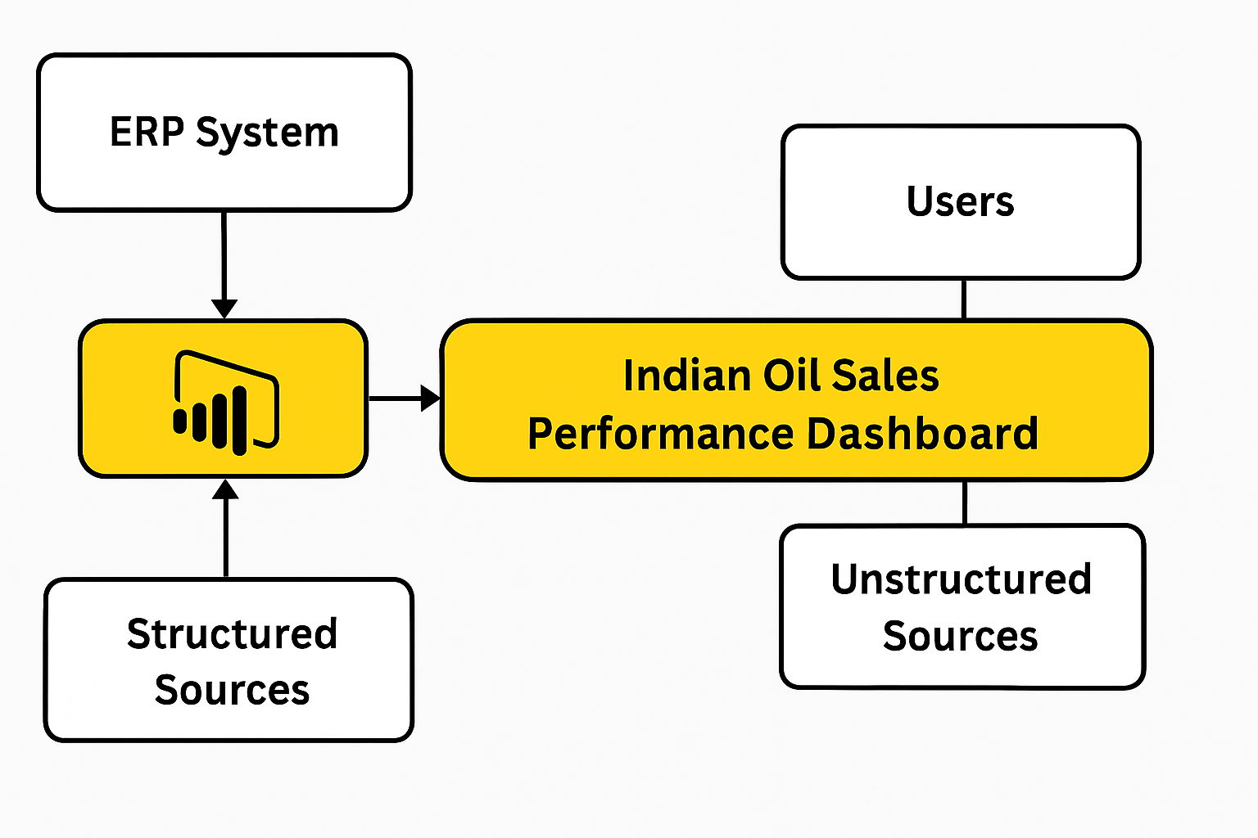
Fig: 3.3 (Context Diagram)

Implementation Methodology
Step 1: Data Collection
Sales data is collected from Indian Oil’s internal sources (e.g., Excel, CSV files) including region, product, and time-based sales.
Step 2: Data Cleaning & Preparation
Using Power Query in Power BI:
- Remove duplicates and null values
- Format columns (e.g., date, numbers)
- Create calculated columns if needed
Step 3: Data Modeling
- Define relationships between tables (e.g., Region ↔ Sales, Product ↔ Sales)
- Use star schema for efficient querying
- Create measures using DAX (e.g., Total Sales, Average Sales
Step 4: Dashboard Design
- Build interactive visuals: bar charts, pie charts, line graphs, maps
- Add slicers for filtering by region, product, and time
- Use bookmarks and tooltips for better user experience
Step 5: Testing
- Functional Testing: Check if filters, visuals, and calculations work correctly
- Data Validation: Cross-check totals with raw data
- User Testing: Get feedback from sample users for usability
Step 6: Defect Log Maintenance
- Maintain a simple Excel sheet to log issues
- Columns: Issue ID, Description, Module, Status, Date Raised, Date Resolved
- Update the log during testing and fix issues before final deployment
Step 7: Report Publishing
- Publish the dashboard to Power BI Service
- Set up scheduled data refresh
- Share with stakeholders via secure links
- ER Diagram (Entity-Relationship)
Entities: Region, Product, Sales
Relationships:
- One region has many sales
- One product appears in many sales
Step 8: Requirement Analysis
- Understand the business goals of Indian Oil: tracking fuel sales, regional performance, and customer trends.
- Identify key stakeholders and their data needs (e.g., sales managers, executives).
- Define KPIs such as total sales, average transaction value, product-wise performance, and regional comparisons.

Step 9: Validation
- Perform unit testing on DAX formulas and visual filters.
- Validate data accuracy by cross-checking with source files or sample calculations.
- Conduct user acceptance testing (UAT) with stakeholders to ensure usability and relevance.
Step 10: Deployment and Sharing
- Publish the dashboard to Power BI Service for cloud access.
- Set up scheduled data refresh to keep insights up to date.
- Share reports with stakeholders via email, Teams, or embedded links.
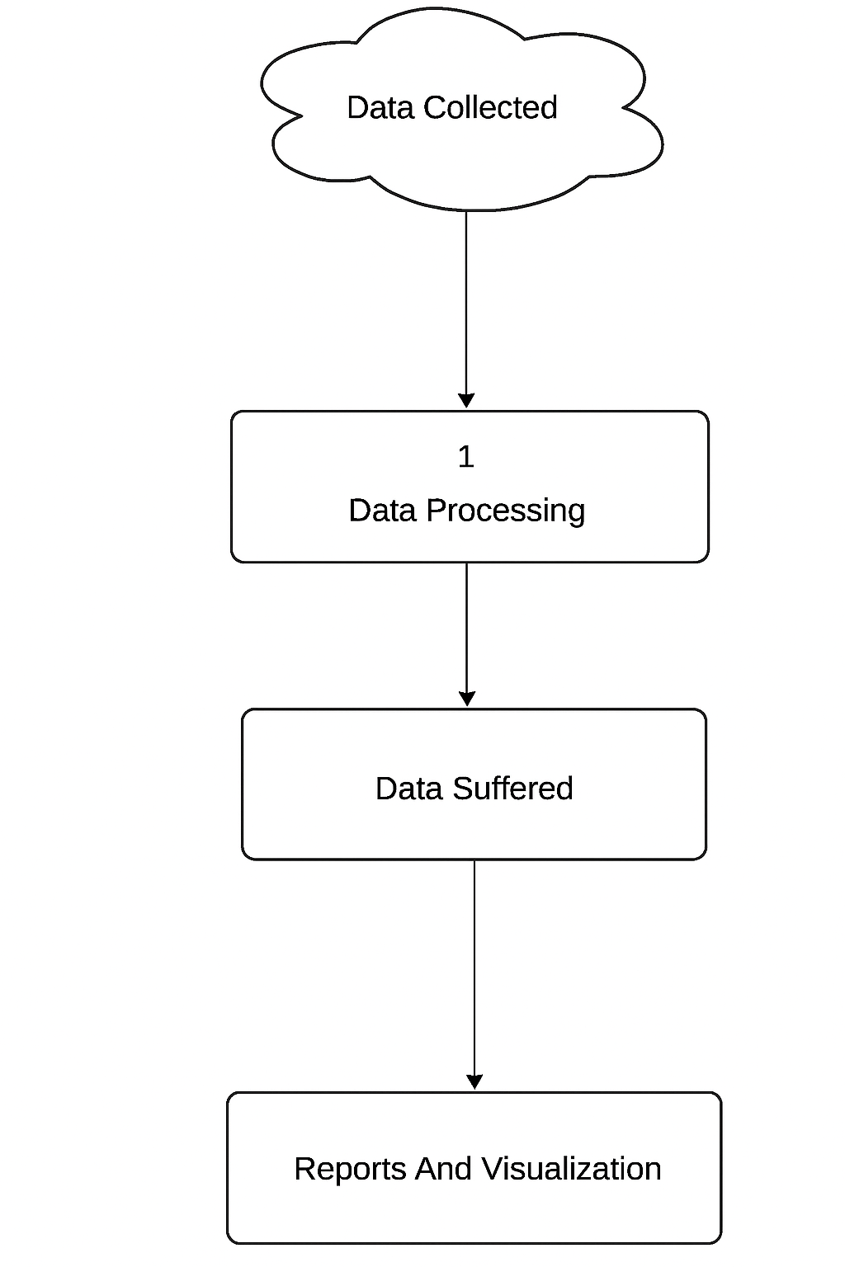
Fig: 4.1 (DFD)

Technologies to be used
- Power BI
For creating dashboards, charts, and interactive reports.
- Microsoft Excel / CSV Files
Used as the source for collecting and storing sales data.
- Power Query
For cleaning and transforming data inside Power BI.
- DAX (Data Analysis Expressions)
To create calculated columns and measures (e.g., Total Sales, Average Sales).
- Power BI Service
For publishing and sharing the dashboard online.

Software Platform
This project uses a combination of front-end and back-end technologies to collect, process, analyze, and visualize Indian Oil’s sales data. The platform is designed to be user-friendly, efficient, and capable of handling large datasets with ease.
- Front-end
The front-end is the part of the system that users interact with directly. In this project, the front-end is built using Power BI, which provides a rich and interactive interface for data visualization.
- Power BI Desktop: Used to design and develop dashboards, charts, and reports. It allows users to create visuals like bar graphs, pie charts, line charts, and maps to represent sales data clearly.
- Power BI Service: After development, the dashboard is published to Power BI Service, where it can be accessed online by stakeholders. It supports sharing, collaboration, and scheduled data refresh.
- User Interaction Features: Slicers, filters, drill-throughs, and tooltips are added to make the dashboard interactive. Users can explore data by selecting regions, products, or time periods.
- This front-end enables decision-makers to gain insights from the data without needing technical knowledge.
- The front-end (Power BI Dashboard) provides a visual and interactive experience for users.

- Back-end
The back-end handles data storage, processing, and logic. It ensures that the data used in the front-end is clean, structured, and ready for analysis.
- Data Sources: Sales data is collected from Excel files or CSV formats, which include fields like region, product type, quantity sold, and sales amount.
- Power Query: This tool within Power BI is used for data cleaning and transformation. It removes duplicates, fills missing values, formats columns, and prepares the data for analysis.
- Data Modeling: Tables are linked using relationships (e.g., Region ↔ Sales, Product ↔ Sales). A star schema is used to optimize performance and simplify queries.
- DAX (Data Analysis Expressions): DAX is used to create calculated columns and measures such as Total Sales, Average Sales, and Year-over-Year Growth. These calculations power the visuals in the dashboard.
• The back-end (Excel/CSV, Power Query, DAX) handles data preparation, modeling, and logic.

Hardware Platform
To successfully develop and run the Power BI-based sales analysis project, the following hardware and software components are recommended:
Minimum Hardware Requirements

Tools, if any
1. Power BI Ecosystem
- Power BI Desktop: For designing data models, creating visuals, and building dashboards.
- Power BI Service: For publishing, sharing, and scheduling data refreshes.
- Power BI Gateway: To connect on-premises data sources securely to the cloud dashboard.
2. Data Sources & Integration
- Microsoft Excel / CSV Files: For importing structured sales data.
- SQL Server / Oracle DB: For accessing transactional and historical sales records.
- ERP Systems (e.g., SAP, Tally): Core source of operational and sales data.
- Web APIs / JSON Feeds: For integrating external metrics like fuel prices or weather.
3. Data Transformation & Modeling
- Power Query (M Language): For data cleaning, shaping, and transformation.
- DAX (Data Analysis Expressions): For creating calculated columns, measures, and KPIs.
- 4. Visualization & Reporting
- Custom Visuals: Advanced charts like decomposition trees, KPI cards, and maps.
- Bookmarks & Drill throughs: For interactive navigation and detailed analysis.
- 5. Collaboration & Governance
- Microsoft Teams / SharePoint: For sharing dashboards and collaborating with stakeholders.
- Row-Level Security (RLS): To restrict data visibility based on user roles.

Advantages of this Project
- Improved Decision-Making
Managers can quickly understand sales trends and make smarter business choices.
- Time-Saving Visuals
Interactive dashboards replace manual reports, saving time and effort.
- Real-Time Insights
With scheduled data refresh, users get up-to-date sales performance anytime.
- Easy Data Exploration
Filters and slicers allow users to explore sales by region, product, or time.
- Error Reduction
Automated calculations and visuals reduce human errors in analysis.
- Scalable and Shareable
Dashboards can be shared online and scaled for different departments or regions.
- Better Resource Allocation
Helps identify low-performing areas and products, guiding marketing and supply decisions.

Assumptions, if any
1. Data Availability & Quality
- Sales data from ERP, Excel, and SQL sources is complete, accurate, and regularly updated.
- External data (e.g., fuel prices, weather) is accessible via reliable APIs or structured feeds.
2. User Roles & Access
- Business users (e.g., managers, analysts) have appropriate access rights to view relevant dashboards.
- Role-based access control (RBAC) is implemented using Power BI Row-Level Security (RLS).
3. Infrastructure & Connectivity
- Power BI Gateway is configured for secure access to on-premises data sources.
- Network connectivity between data sources and Power BI Service is stable and monitored.
4. Dashboard Usage
- Users are trained to interpret visualizations and KPIs correctly.
- The dashboard is used for strategic planning, performance tracking, and operational decisions.
5. Refresh & Update Frequency
- Data refresh schedules are aligned with business needs (e.g., daily, weekly).
- Any latency in data updates is acceptable within defined thresholds.
6. Compliance & Governance
- Data handling complies with internal policies and government regulations (e.g., GST, fuel pricing norms).
- Audit trails and version control are maintained for dashboard changes.

Future Scope and further enhancement of the Project
The Indian Oil Sales Performance Dashboard using Power BI has strong potential for future expansion and strategic impact. The following enhancements can elevate its utility, scalability, and business value:
Future Scope
- Live Data Integration
Enable real-time data streaming from ERP systems and IoT sensors to support instant decision-making.
- Predictive Analytics
Incorporate machine learning models to forecast fuel demand, seasonal trends, and regional performance.
- Mobile Dashboard Access
Optimize dashboards for mobile devices to empower field executives and regional managers with on-the-go insights.
- Customer Behavior Analysis
Integrate CRM data to analyze buying patterns, loyalty metrics, and customer segmentation.
- Geo-Mapping & Spatial Analysis
Use Power BI’s map visuals to track sales by geography, identify underperforming regions, and optimize distribution.
- Alert & Notification System
Set up threshold-based alerts for anomalies in sales, inventory, or pricing to trigger proactive actions.
- Multi-Department Integration
Expand dashboard coverage to include finance, logistics, and marketing for cross-functional visibility.
- AI-Powered Insights
Leverage Copilot in Power BI to generate natural language summaries and suggest actionable recommendations.

Project Repository Location

S# | Project Artifacts (softcopy) | Location  (Mention Lab-ID, Server ID, Folder Name etc.) | Verified by Project Guide | Verified by Lab In-Charge
 | Project Synopsis Report (Final Version) |  | Name and Signature | Name and Signature
 | Project Progress updates |  | Name and Signature | Name and Signature
 | Project Requirement specifications |  | Name and Signature | Name and Signature
 | Project Report (Final Version) |  | Name and Signature | Name and Signature
 | Test Repository |  | Name and Signature | Name and Signature
 | Project Source Code (final version) with executable |  | Name and Signature | Name and Signature
 | Any other document |  | Name and Signature | Name and Signature

Definitions, Acronyms, and Abbreviations

Abbreviation | Description
SRS | Software Requirements Specification – a formal document outlining system needs
POWER BI | A business analytics tool by Microsoft for interactive data visualization
DAX | Data Analysis Expressions – formula language used in Power BI
M LANGUAGE | Power Query Formula Language used for data transformation in Power BI
ERP | Enterprise Resource Planning – software systems managing core business processes
SQL | Structured Query Language – used for managing relational databases
KPI | Key Performance Indicator – measurable value indicating business performance
RLS | Row-Level Security – Power BI feature to restrict data access per user role
ETL | Extract, Transform, Load – process of preparing data for analysis

Conclusion
The development of the Indian Oil Sales Performance Dashboard using Power BI has successfully addressed the core objective of transforming raw sales data into actionable insights. By integrating structured and unstructured data sources, applying dynamic visualizations, and enabling real-time performance tracking, the system empowers decision-makers to monitor trends, identify bottlenecks, and optimize operations across regions. The Indian Oil Sales Analysis project successfully demonstrates how modern data visualization tools like Power BI can transform raw sales data into meaningful business insights. The innovative use of interactive dashboards, dynamic filters, and real-time data refresh sets this project apart from traditional reporting methods.
Key achievements include:
- Clean and structured data modeling using Power Query and DAX
- Region-wise and product-wise sales comparison through intuitive visuals
- User-friendly interface for quick decision-making and performance tracking
What makes this system stand out is its scalability, ease of use, and potential for future enhancements like predictive analytics and mobile access. By integrating technology with business intelligence, this project supports smarter planning and efficient resource allocation for Indian Oil.
This project demonstrates how digital tools can enhance transparency, agility, and strategic alignment in a large-scale public sector enterprise. The use of Power BI ensures scalability, ease of use, and integration with existing ERP systems, making it a cost-effective and sustainable solution.
Recommendations
- Institutional Adoption: Expand dashboard usage across departments (e.g., logistics, finance) to foster data-driven culture.
- Training & Change Management: Conduct workshops for regional managers and analysts to ensure effective utilization and reduce resistance to digital tools.
- Budget Allocation: Allocate funds for periodic upgrades, data quality audits, and integration of predictive analytics modules.
- Policy Alignment: Ensure dashboard metrics align with government fuel pricing policies and environmental regulations.
- Performance Incentives: Link dashboard KPIs to employee performance metrics to encourage proactive sales strategies.
These recommendations are practical and justified given the dashboard’s ability to reduce manual reporting, improve decision speed, and enhance accountability. With minimal financial overhead and strong managerial support, this system can be a cornerstone of Indian Oil’s digital transformation journey.

References
S.No. | Title | Report No. / Version | Date | Publishing Organization | Source / Access
1 | Power BI Documentation | N/A | Updated 2025 | Microsoft Corporation | Power BI documentation - Power BI | Microsoft Learn
2 | DAX Reference Guide | N/A | Updated 2025 | Microsoft Corporation | Power BI documentation - Power BI | Microsoft Learn
3 | Power Query M Formula Language Specification | N/A | Updated 2025 | Microsoft Corporation | Power BI documentation - Power BI | Microsoft Learn
4 | Indian Oil Corporation Annual Report | 2023-24 | March 2024 | Indian Oil Corporation Ltd. | IndianOil | The Energy of India | Indian Oil Corporation Ltd.
5 | SQLBI DAX Patterns | N/A | 2023 | SQLBI | IndianOil | The Energy of India | Indian Oil Corporation Ltd.
6 | Kaggle Fuel Sales Dataset | Dataset ID: fuel-sales-23 | 2023 | Kaggle Inc. | RFC 4180: Common Format and MIME Type for Comma-Separated Values (CSV) Files
7 | RFC 4180: Common Format and MIME Type for CSV Files | RFC 4180 | October 2005 | IETF (Internet Engineering Task Force) | RFC 4180: Common Format and MIME Type for Comma-Separated Values (CSV) Files

Reference Details :

S# | Reference Details | Owner | Version | Date
 | Project Synopsis | <Project Group ID> | 1.0 | DD-MM-YY
 | Project Requirements | <Project Group ID>

Annexure A
Data Flow Diagram (DFD)

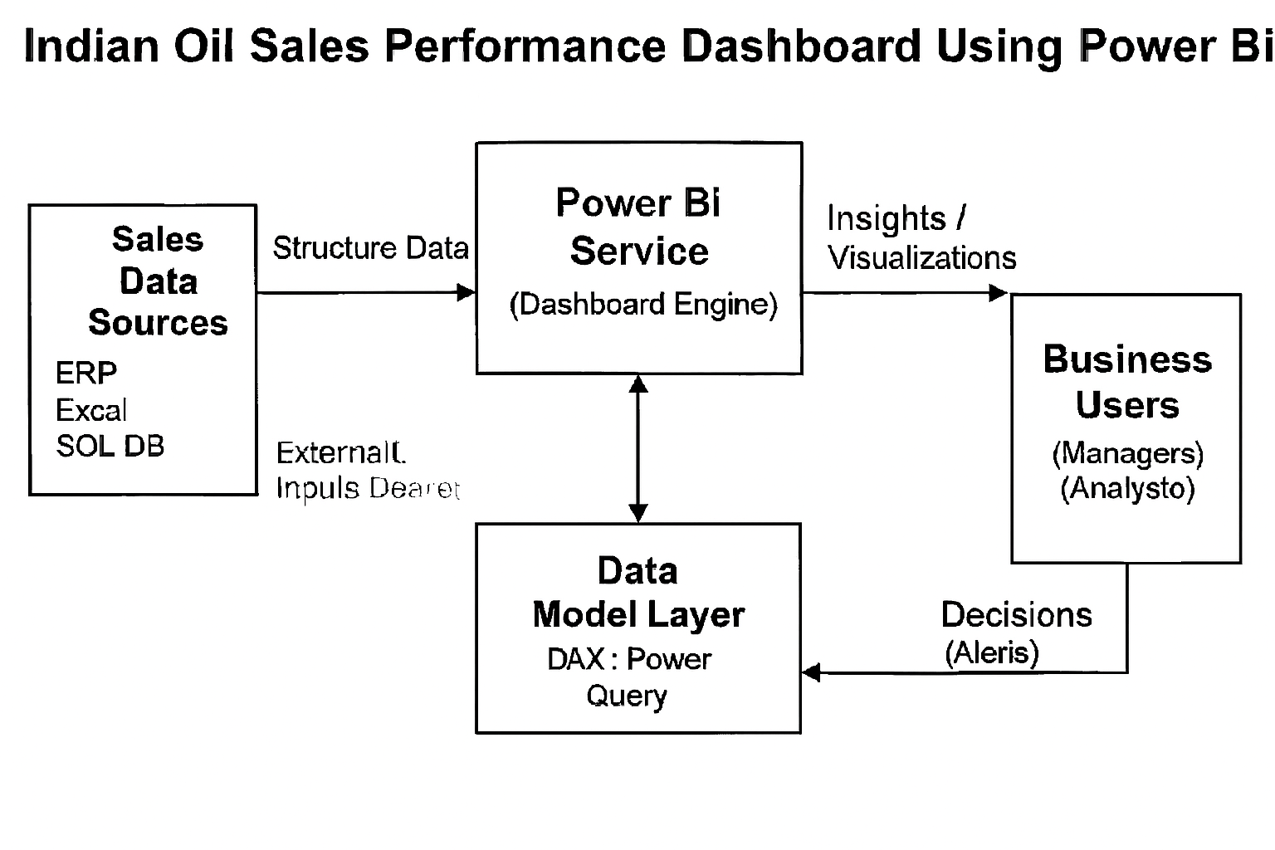

Annexure B
Entity-Relationship Diagram (ERD)

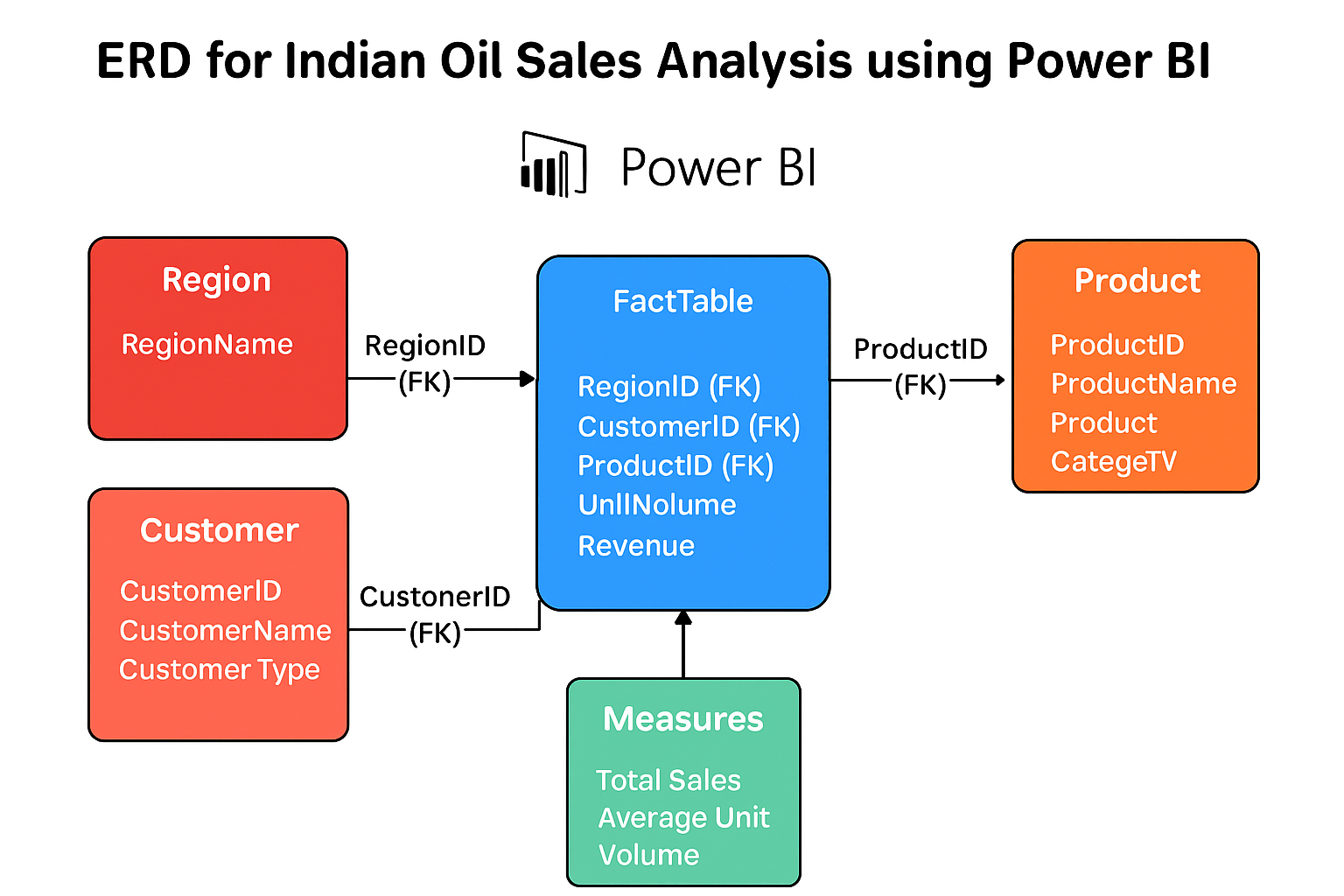

Fig. (ERD-Entity Relationship Diagram)

Annexure C
Use-Case Diagram (UCD)

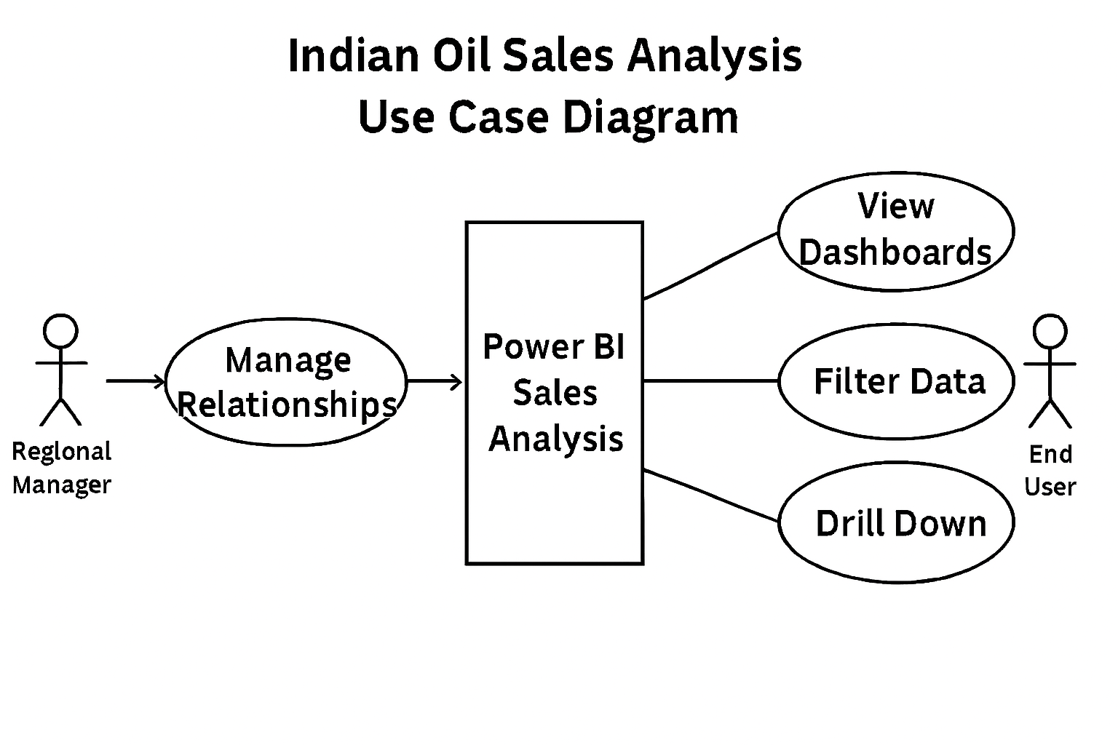

Annexure D
Data Dictionary (DD)

Example:
User Table (USR)
Fields | Data type | Description
USR-Name | VARCHAR | Admin name(Worker)
USR-Password | VARCHAR | Admin password(supplier)
USR-Contact-No | INT | Admin Contact(supplier/student)
USR-Address | VARCHAR | City(supplier city)

Supplier Table (SUPP)
Fields | Data type | Description
SUPP-ID | INT | Supplier ID
SUPP-Name | VARCHAR | Supplier Name
SUPP-Address | VARCHAR | Supplier Address
SUPP-Contact | INT | Supplier Contact
SUPP-Credit-Limit | INT | Credit Limit

Annexure E
Screen Shots

